Meta title: Find a Top Personal Care Attendant Near Me
Meta description: Discover the peace of mind that comes with hiring a "personal care attendant near me." Learn about cost-effective options, manage daily living activities, and explore funding through insurance or agencies to ensure quality care for loved ones.

Finding the Best Personal Care Attendant Nearby

Do you find yourself checking your phone constantly while at work, worrying that your dad might slip in the shower or forget to turn off the stove? That persistent anxiety is often the loudest signal that "helping out" has evolved into a full-time safety risk. Family care experts agree that acknowledging this tipping point isn't a failure, but a necessary step toward reclaiming your role as a son or daughter rather than an overwhelmed nurse.
Searching for a "personal care attendant near me" offers a practical solution by bringing in a professional to act as an extra pair of hands. Unlike medical staff who manage prescriptions or wounds, these attendants focus on non-medical "Activities of Daily Living" (ADLs)—routine tasks like bathing, dressing, and meal preparation. By handling these essential support services, a PCA allows your loved one to remain comfortable in their own home while giving you peace of mind.
While the emotional relief is immediate, funding and managing this care is the next critical hurdle. This guide cuts through the confusion to help you assess your specific senior care needs and navigates the three primary paths to payment: private funds, insurance coverage, and state-based Medicaid options.

Living vs. Healing: Why a Personal Care Attendant is the 'Extra Pair of Hands' You Need
If you are worrying about managing IVs or complex wound care, you likely need a medical professional. However, most families searching for help are actually struggling with the daily grind of life—what the industry calls custodial care. This support focuses on keeping your loved one safe and comfortable rather than providing medical treatment. This distinction prevents you from overpaying for a personal care assistant vs home health aide when you simply need reliable, non-medical help to keep the household running smoothly.
Think of a PCA as an extension of your own family, stepping in to handle routines that have become difficult or dangerous. These tasks generally fall into two categories: immediate physical needs and broader household management, known technically as Instrumental Activities of Daily Living (IADLs). A qualified attendant generally manages:
- Physical Care: Bathing, dressing, grooming, toileting, and safe movement around the home.
- IADLs: Meal preparation, grocery shopping, light housekeeping, and medication reminders.
Clear role definitions help secure activities of daily living support services without blowing your budget on clinical rates. You do not need to pay for a medical degree to get a healthy dinner cooked or to ensure Mom gets safely into the shower. Once you recognize that a PCA covers the "living" side of the equation, determining how quickly you need to act becomes the priority.

Stop Guessing: 5 Red Flags That Your Loved One Needs In-Home Support Today
It is common to dismiss small changes as just "part of aging," but ignoring subtle shifts in your loved one’s routine can lead to preventable accidents. Often, family members don't realize senior safety at home has been compromised until a fall happens or a stove is left on. Shift from passive worrying to active observation to determine if their independence is becoming a liability.
Look for these five concrete indicators that the daily demands have exceeded their ability to cope alone:
- Unexplained Weight Loss: They may be skipping meals because cooking is too exhausting or dangerous.
- Hygiene Decline: Wearing soiled clothes or fearing the shower usually points to a lack of physical support.
- Household Disarray: Stacks of unpaid bills, scorched pots, or unwashed laundry piling up.
- Missed Medication: Full pillboxes at the end of the week or confusion about dosages.
- Social Withdrawal: Isolation often stems from embarrassment about their declining abilities or fear of leaving the house.
Identifying these flags allows you to step in with elder care management and navigation strategies before a crisis forces your hand. Acknowledging the need for help is not a failure; it is a safety measure. Once you accept that support is necessary, the urgent question becomes who provides it: a professional agency or an independent hire.

Agency vs. Private Hire: Which Path Protects Your Family and Your Wallet?
Deciding between choosing a licensed home care agency and hiring an independent worker often comes down to balancing budget against risk. While hiring a neighbor or freelance aide directly may seem cheaper per hour, it unknowingly transforms you into an "unintentional employer." This legal shift means you become responsible for payroll taxes, social security contributions, and potentially workers' compensation if the caregiver slips on your icy driveway.
Agencies charge higher rates specifically to absorb these heavy liabilities for you. Professional providers, including many agencias de home health aide, carry bonding and theft insurance, creating a financial safety net that private arrangements lack. Furthermore, agencies solve the "call-out" problem; if an agency caregiver gets sick, the company sends a replacement, whereas a private hire’s absence leaves you scrambling to fill the gap immediately.
If your budget dictates that you must learn how to hire a private caregiver for seniors directly, you must replicate the rigorous vetting process an agency would typically handle. Never rely solely on a handshake; ensure you cover these three specific background check criteria for in-home workers:
- Criminal History: Run a check on both state and national databases, not just local files.
- Driving Record: Critical if the aide will be transporting your loved one to appointments.
- Abuse Registry: Verify the candidate does not appear on state-level elderly abuse or sex offender registries.
With the hiring path selected, the focus shifts to the practical reality of payment options.

Navigating the Three Doors of Funding: How to Pay for Care Without Draining Savings
Facing the financial reality of home care is often the most stressful part of the journey. Because Medicare generally does not cover custodial help—like bathing or meal prep—most families initially rely on savings. With the average cost of non-medical senior care hovering between $27 and $35 per hour nationally, expenses can mount quickly. Knowing where you fit in the funding landscape is the first step toward protecting your family's assets.
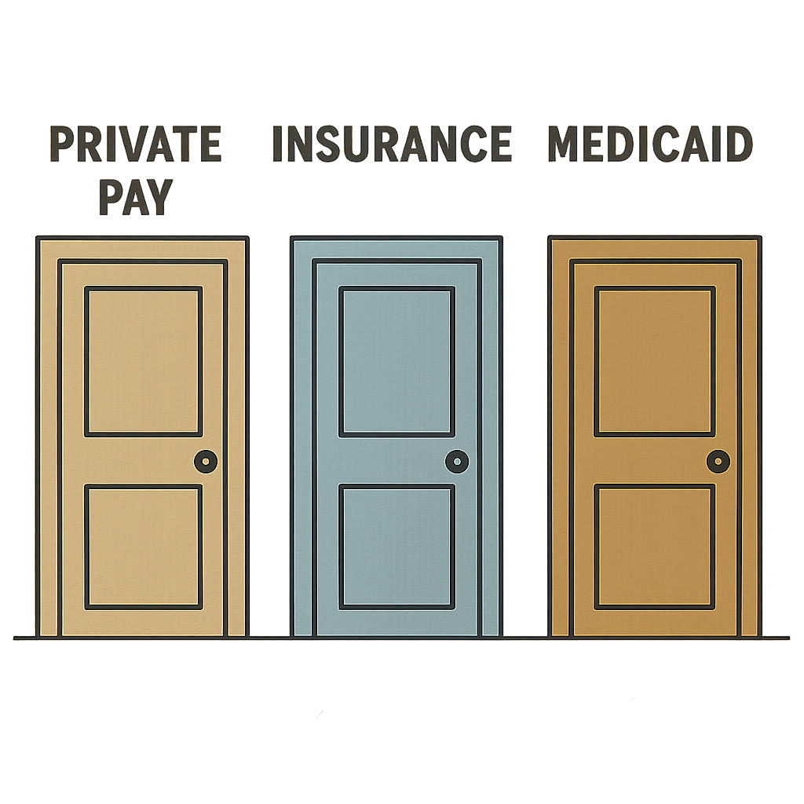
If your loved one holds a policy, long-term care insurance coverage for caregivers can be a game-changer, but it rarely pays out on day one. Most policies include an "elimination period"—essentially a deductible measured in time rather than dollars. You typically must pay out-of-pocket for the first 30, 60, or 90 days of care before the insurer begins reimbursing expenses.
To effectively fund care, visualize your strategy as opening one of these three distinct doors:
- Private Pay: The default door where families pay cash; this offers the most flexibility in choosing who you hire but drains savings fastest.
- Insurance: A reimbursement door that requires navigating policy limits and satisfying the elimination period before relief arrives.
- Medicaid Waivers: The government door for those with limited assets; unlike standard health coverage, a Medicaid waiver for home-based services specifically redirects nursing home funds to pay for care in your own living room.

Mastering the Interview: 10 Questions to Separate Pro Caregivers from Amateurs
Hiring someone to care for a loved one requires more than just checking off certifications; you need to gauge reliability and temperament before handing over the house keys. While resumes list skills, effective interview questions for private duty staff reveal character. Focus on behavioral inquiries—scenarios that force candidates to explain how they think rather than just reciting "yes" or "no."
- Tell me about your previous caregiving experience.
- How do you handle a client who refuses to bathe?
- What specific steps do you take in a medical emergency?
- How do you manage stress or frustration on the job?
- Are you comfortable preparing meals for specific diets?
- Describe a time you noticed a subtle change in a client’s health.
- How do you react to constructive criticism?
- What is your backup plan if your car breaks down?
- Why do you prefer home care over facility work?
- Can you provide three professional references?
Verbal answers must align with practical ability. If your family member requires mobility assistance for homebound individuals, ask the candidate to describe a safe transfer technique. A professional knows how to pivot a client from bed to wheelchair without strain, whereas hesitation here poses a significant fall risk.
Pay close attention to how the candidate reacts to hypothetical stress, especially regarding cognitive decline. For specialized dementia care at home, ask: "What do you do if a client accuses you of stealing?" A defensive answer is a red flag, while a calm explanation of redirection techniques indicates a seasoned pro. Trust your instincts—if the conversation feels forced, the care relationship likely will be too.

Specialized Support: Managing Dementia, Mobility, and Hospital-to-Home Transitions
While basic companionship covers conversation, loved ones with memory loss often require more tactical support to manage behavioral changes. Late-afternoon confusion, commonly known as "sundowning," can quickly turn a calm environment into a source of severe anxiety for seniors. A PCA trained in specialized dementia care at home understands that arguing with confused logic is ineffective; instead, they use redirection techniques—like playing a specific song or initiating a familiar task—to gently shift the focus away from distress. This approach transforms a potentially volatile situation into a manageable routine, preserving dignity for the senior and sanity for the household.

Physical safety is equally critical, particularly when simple movements like rising from a recliner become dangerous hurdles. Professional mobility assistance goes beyond merely offering a steady hand; it often involves using specific tools like a "gait belt." This sturdy strap, placed around the waist, allows the caregiver to support the individual’s center of gravity without pulling on fragile arms or shoulders. By mastering these technical transfers, a qualified attendant drastically reduces the risk of in-home falls, ensuring that a necessary trip to the bathroom doesn't end with an emergency room visit.
The days immediately following a medical discharge are statistically the most vulnerable, with many seniors returning to the hospital within a month due to medication errors or exhaustion. Effective transitional care from hospital to home acts as a crucial safety net during this fragile window, ensuring that new prescriptions are picked up and discharge instructions are followed precisely. Having this focused support allows the senior to concentrate entirely on physical recovery, while you gain the necessary breathing room to plan for the emotional demands of long-term caregiving.

The Invisible Burden: How Respite Care Prevents Family Caregiver Burnout
You cannot pour from an empty cup, yet many family members view taking a break as a betrayal rather than a necessity. Respite care benefits for family members are not just about rest; they are a critical component of safety and sustainability. Bringing in a PCA for short-term relief allows you to physically recharge, significantly reducing the chronic stress that often leads to caregiver burnout or unintentional medication errors. It isn't abandoning your duty; it is ensuring you have the stamina to continue it.
Integrating professional support doesn't mean surrendering control; it can happen in small, manageable increments that fit your specific schedule. You might structure this support as:
- Weekly Recharges: A consistent 4-hour block allowing you to handle errands or attend your own medical appointments.
- Sleep Support: Overnight companion care for disabled adults or seniors, ensuring safety while you get a full night of uninterrupted sleep.
- Vacation Coverage: Temporary full-time help to facilitate family getaways without disrupting your loved one’s routine.
Utilizing these pauses changes the dynamic from crisis management to proactive planning. Effective elder care management and navigation requires a clear head, which is impossible to maintain when you are perpetually exhausted. Once you accept that help is necessary for the long haul, the next step is executing a plan to find safe, qualified help immediately.

Your 48-Hour Roadmap to Securing Reliable Help
Finding the right help shifts you from a state of constant worry to one of managed care. You now have the tools to distinguish between a qualified professional and a well-meaning neighbor, ensuring your loved one receives support without compromising safety. This isn't just about filling a schedule; it is about building a sustainable senior care roadmap that allows everyone in the family to breathe easier.
Turn this knowledge into a hire with this immediate action plan:
- Assess needs: Write down the specific ADLs (like bathing or meal prep) required for the day.
- Check funding: Confirm if insurance, Medicaid, or private funds will cover the costs.
- Call 3 agencies: Compare rates and background check processes to find the best local fit.
- Interview candidates: Ask scenario-based questions to test reliability and empathy.
- Start a trial day: Schedule a short shift to observe the chemistry before committing long-term.
As you execute your search for a "personal care attendant near me," remember that you don't need to commit to a full-time schedule instantly. Learning how to hire a private caregiver for seniors effectively often starts with a single step: the trial run. Schedule that first 4-hour shift and watch how a professional presence changes the atmosphere of the home. You are taking a powerful step toward preserving your loved one’s independence and reclaiming your own peace of mind.

